16th Annual

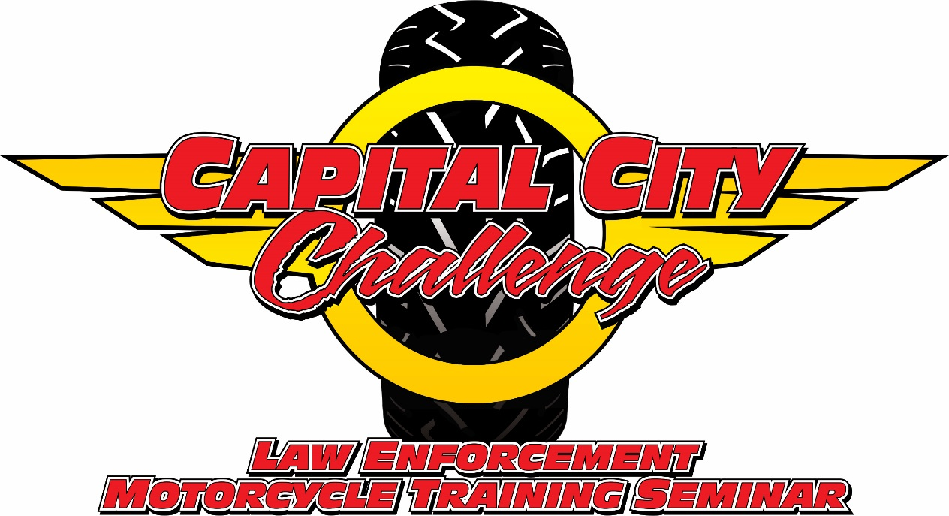

May 27rd-30th, 2020
8am-4pm
At FSU’s Doak Campbell Stadium
403 Stadium Drive
Tallahassee, FL 32306

Hosted by
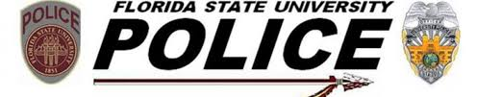

Benefitting Special Olympics Leon County

For more information, please visit us at www.CapitalCityChallenge.com

